**Managing AWS EC2 instances**

On Demand instances - Pay as you pricing model, no contracts. Great for workload uncertainty, commitment free usage, experimentation

**Key Concept :** Availability Zones and Instance Types

Each regions are completely isolated from each other to provide fault tolerant and HA system. if one region gets affected the other one would be completely unaffected.

**Instance Type :** Allow you to specify the hardware of the host computer to accommodate your applications need

**Instance Families**

* General purpose
* Compute Optimized
* Memory Optimized
* Storage Optimized
* Accelerated computing

======================================

**Launching an on-demand instance**

Global search - EC2 - Launch Instance - Choose AMI(Amazon machine Image) - Instance type - select instance - Storage –

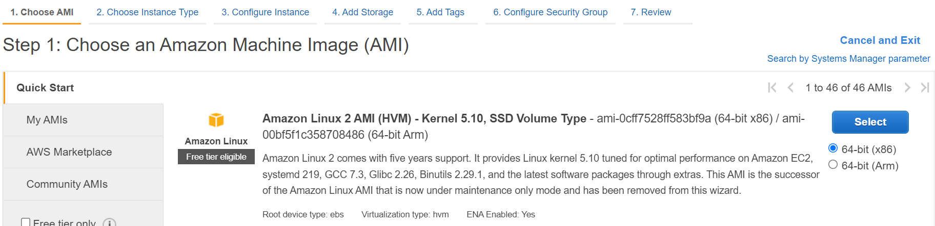

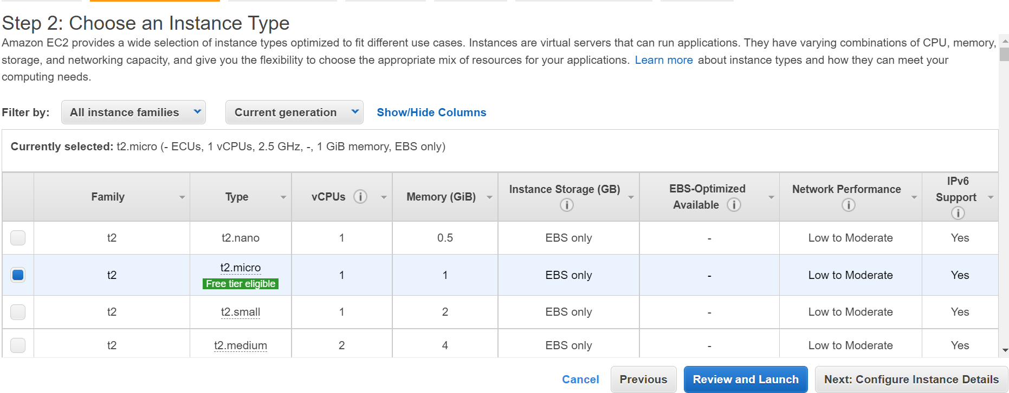

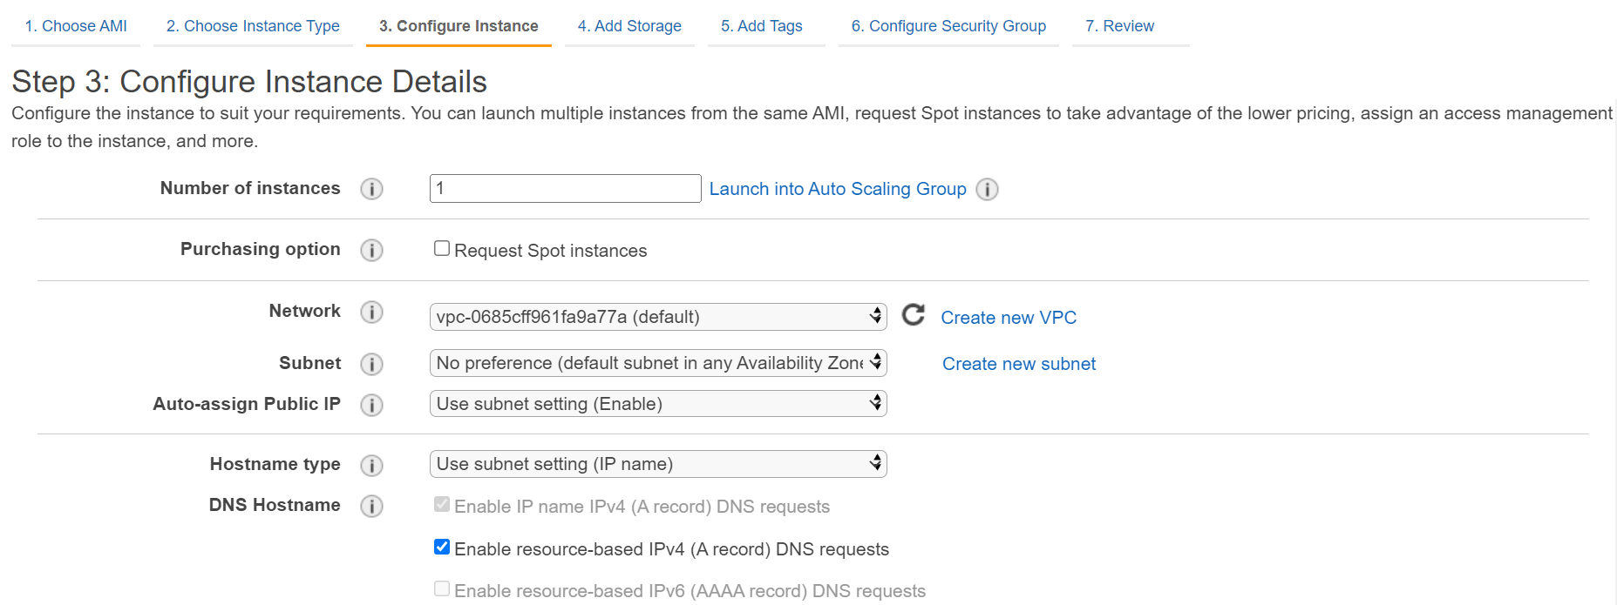

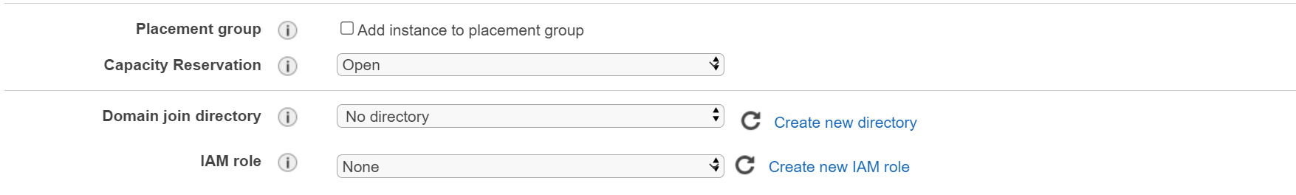

by Default EC2 instance with have an HTTP endpoint that we can access to view its metadata.

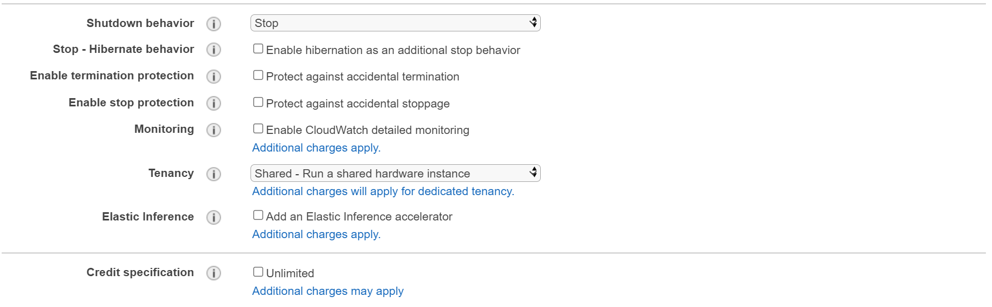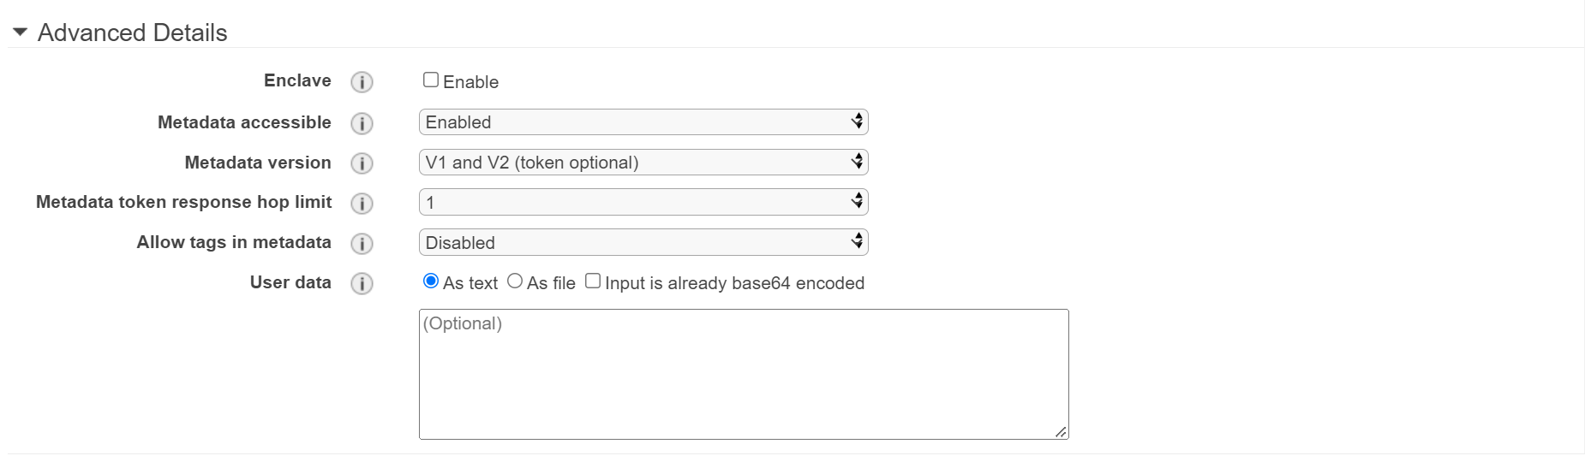

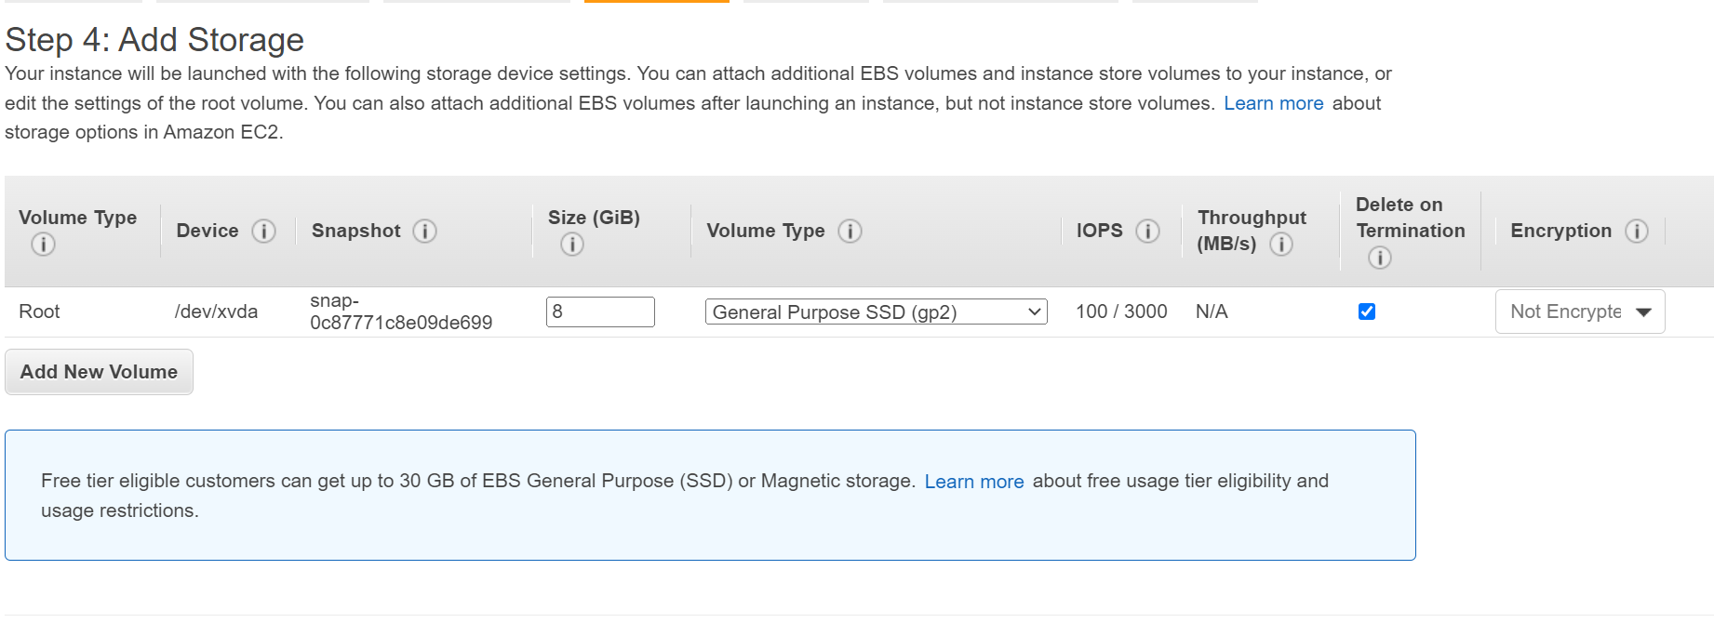

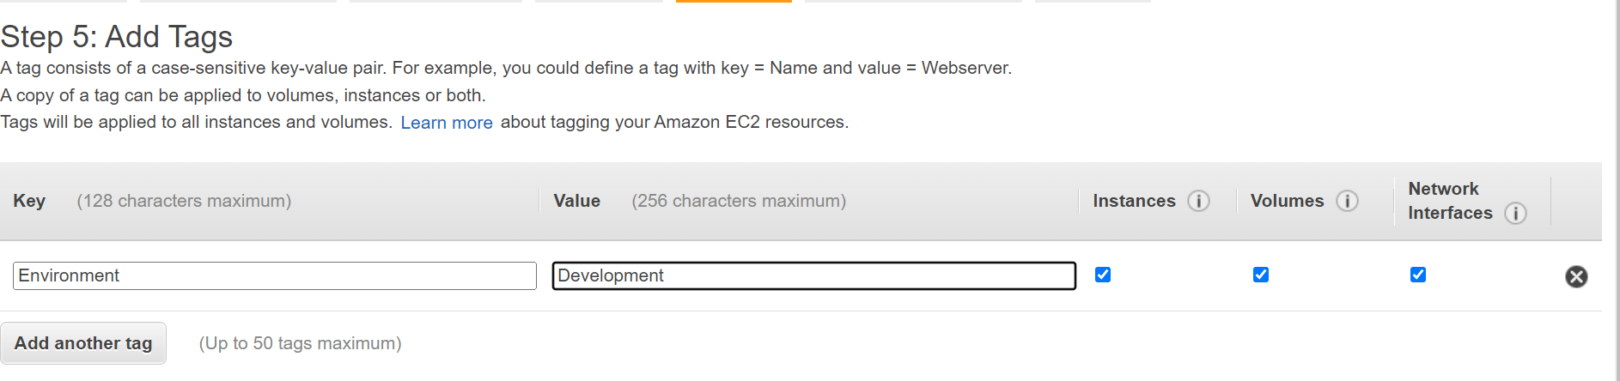

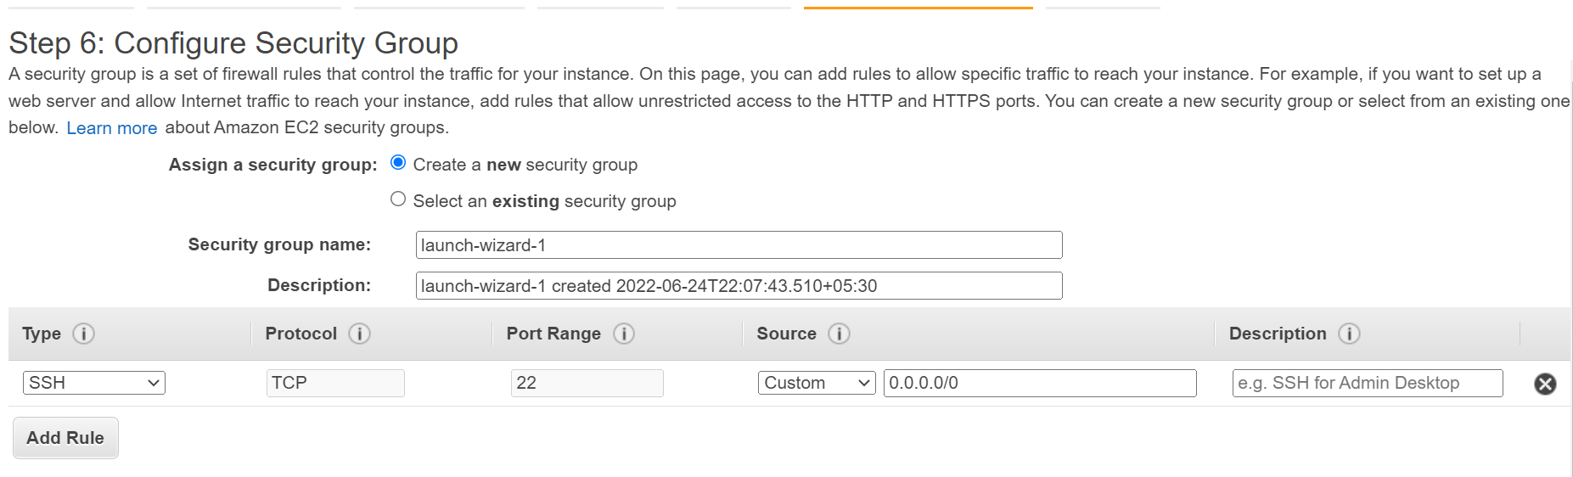

Need to specify a key pair to use. A key pair is a file that we're going to keep on our local machine that allows to connect to our instance. We can use an existing key or create a new one.  
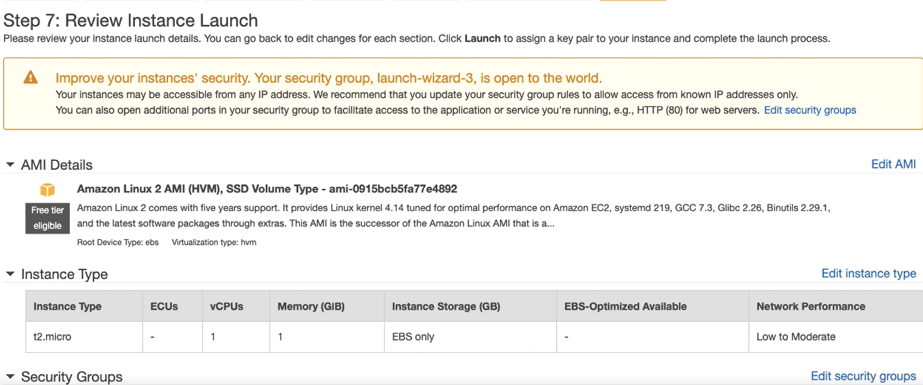

**Reserved instance**

Types - Standard, convertible, scheduled

Upon launching RI you're going to need to make some choices as to what it is you need from an instance.

**Configuration options** - Platform, tenancy, offering class, instance type, term, Payment option

**Instance type** - become familiar with your applications need in advance. on demand instances can be used for experimentation.

**Platform -** multiple flavors of linux, Windows.

**Tenancy -** default and dedicated

**Payment option -** all upfront, partial upfront. noupfront

**Term -** 1-12, 12-36 months  
==================================================================================

**Reserved instance type 2 - convertible reserved instances.**

offering class - standard, convertible  
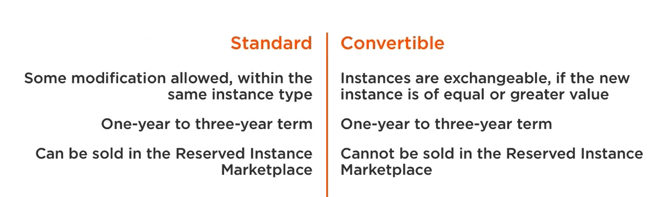

**Availability Zone**

Regional instances apply a disc across all avail zones  
Reserving capacity in a single availability zone grants them priority

**Scheduled Reserved instances :** reserve compute capacity on Daily, weekly or monthly basis. Predictable, scheduled workloads. Great for running maintenance task.

**What if no longer need reserved instance :** Amazon reserved instance marketplace

* Buy and sell RI
* Terms shorter than one year available
* entire process handled through amazon.
* the quality of instance is no different

RI use cases : Best suited for steady state workloads, will be used in a long term, will be frequently

**Launch Reserved instance  
  
On EC2 Dashboard**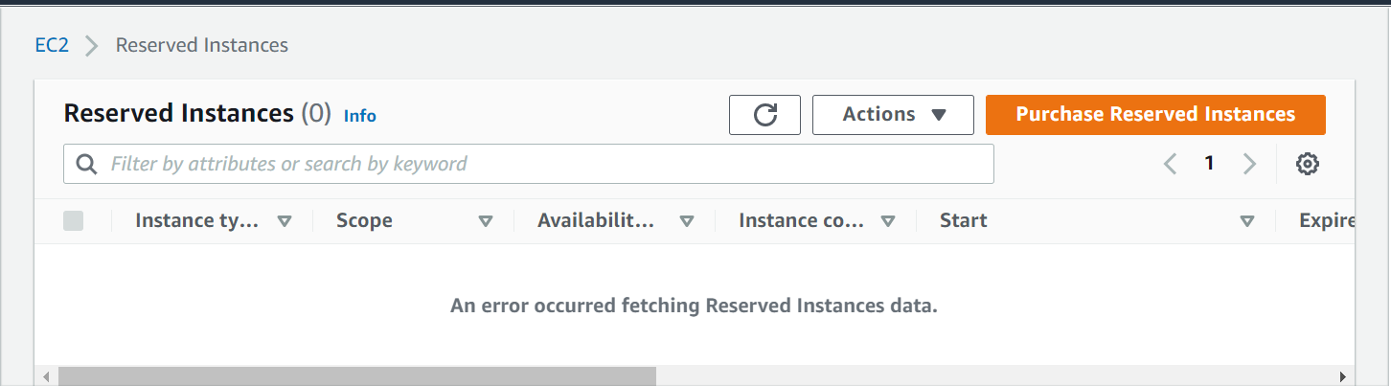

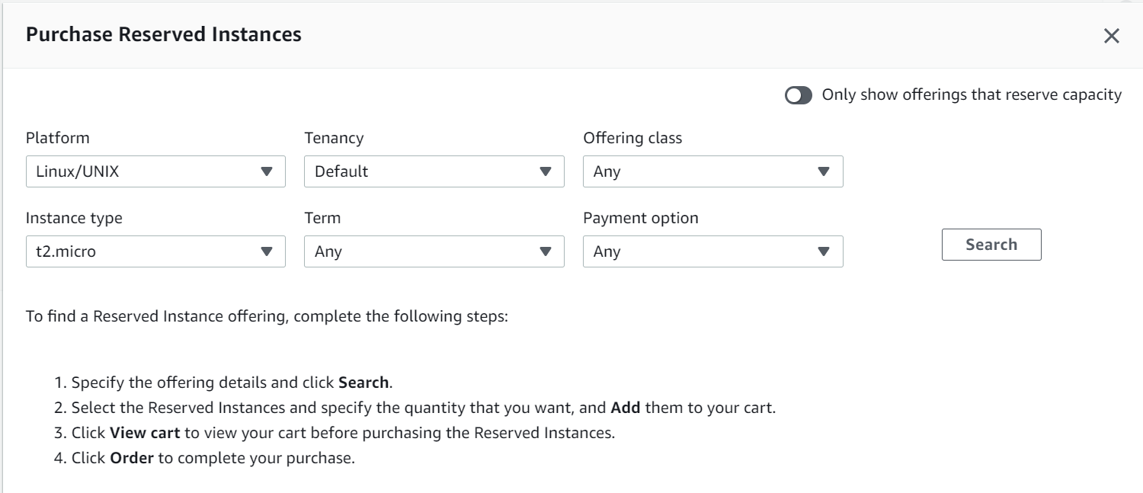

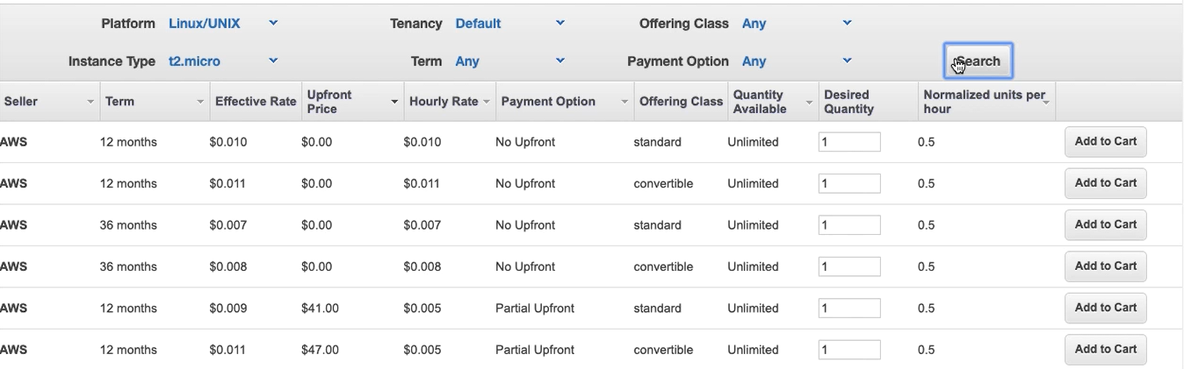

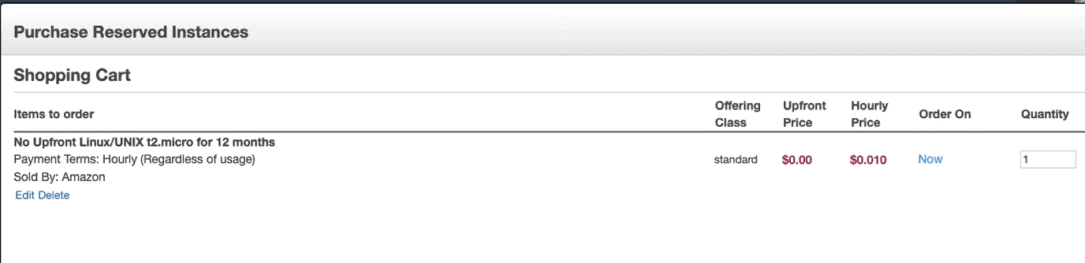

**Spot Instances**

* Unused resources for up to a 90% disc
* Greta to run alongside existing infra

Amazon can interrupt your service : interruption notices give a 2 min warning before shutdown  
  
**Interruption causes** : Price, capacity, Constraints

**Price:** hourly price is called the spot price. The price varies over gradual supply and demand trends. you submit one time or persistent req if the spot price exceeds your request price, your instance will be terminated.

Spot block : Allows you to submit a reqq to purchase a spot instance for a block of time between 1 and 6 hrs.

**Capacity :** there needs to available, unused resources

**Constraints :** the more specific you are with what you want, the less chance there will be an available instance.

**Launch Spot Instance**

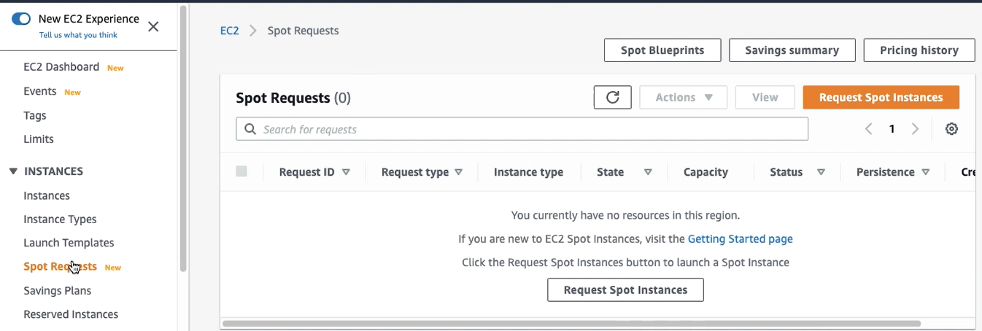  
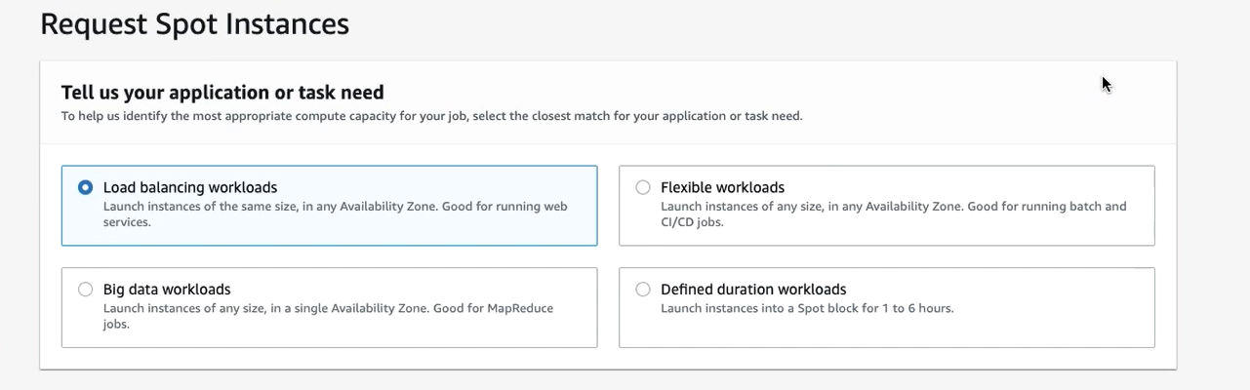

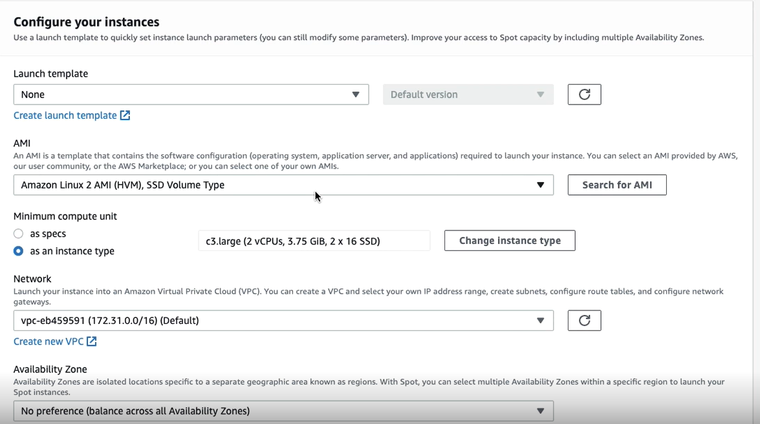

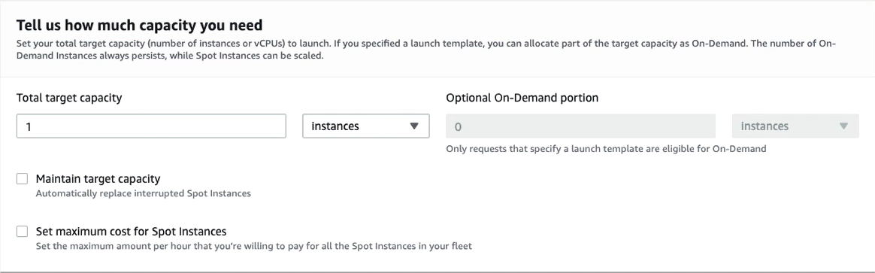  
  
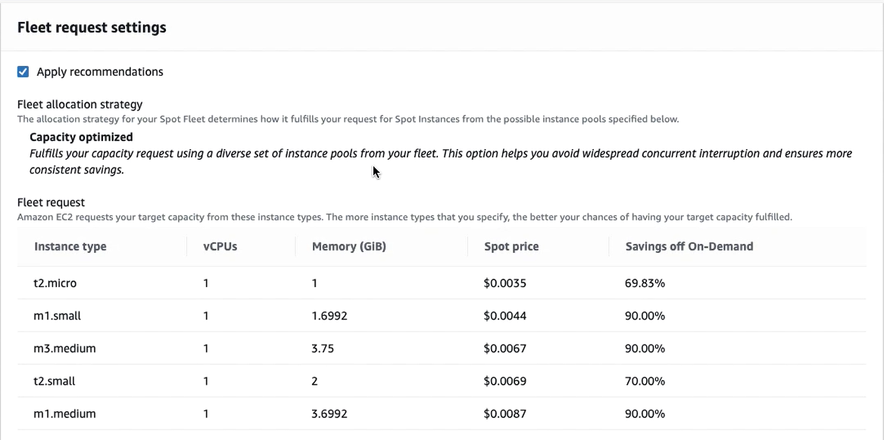

**Dedicated instance**

* By default, EC2 instances are share hardware
* Dedicated instances and host are the exception to this
* Costs more than other instances
* used to meet regulatory req or H/W based licenses.

Shared Instances

dedicated hardware

dedicated host

**Launch dedicated host  
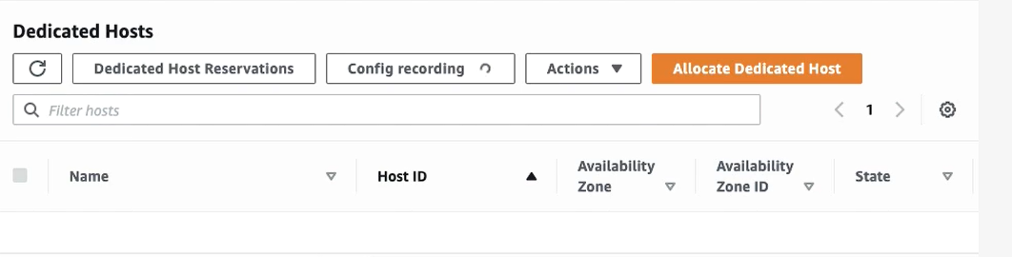**

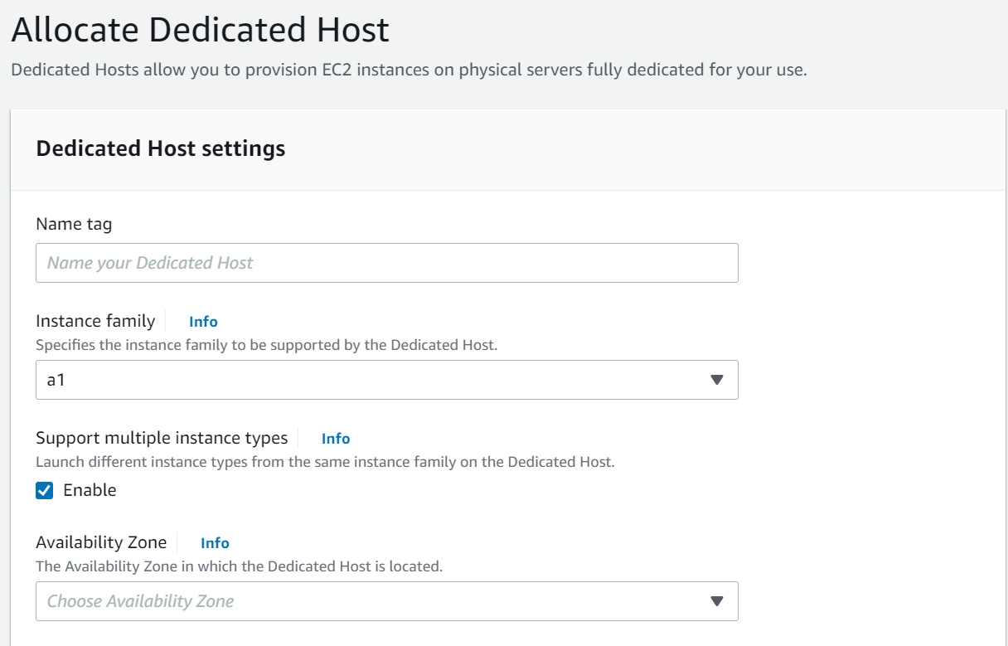

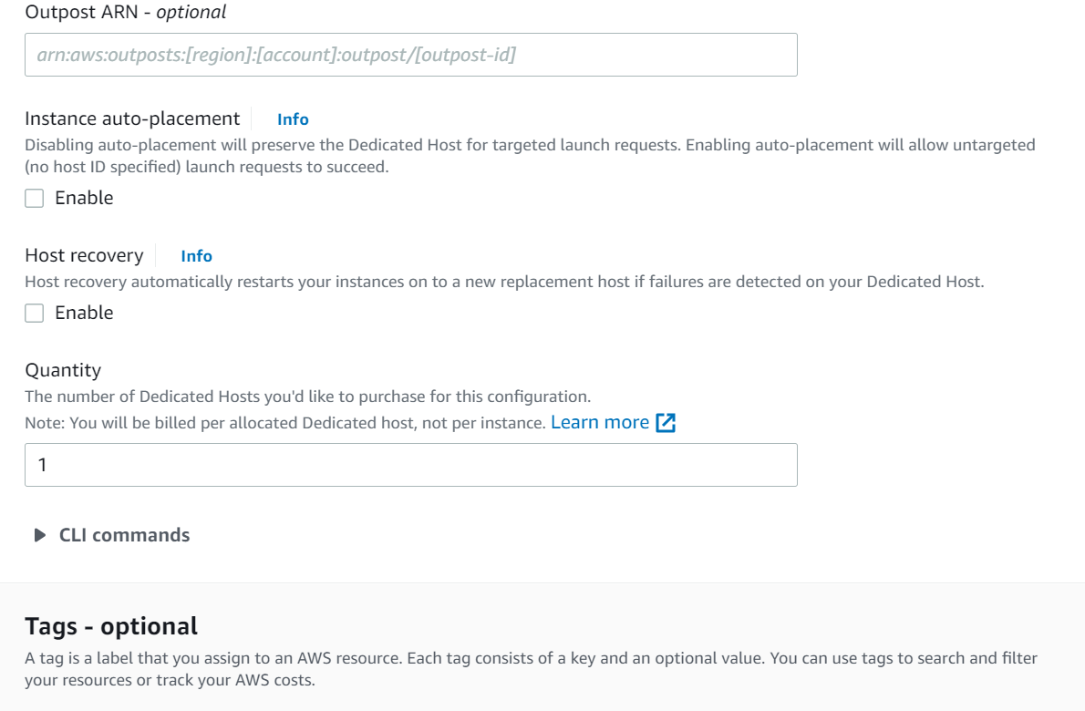**and Allocate**

**AMI - Amazon machine images**

* Bundle up functionality and software
* Acts as a template for new instances
* Helps you be efficient and save time
* allow for scalability

**Components of ami** - root volume template, launch permissions, block device mapping

Root volume template ; The root volume can be looked at as hardware drive. the template stores the OS, software, source code

Launch permissions: specified which aws acc can use this ami to launch instances

Block device mapping : EC2 instances are not limited to one volume. Specifies which vol to attach to the instance to be launched

AMI Management

* Creating an ami register
* launch, customize and save again
* assign tags to keep the organized
* deregister when no longer in need

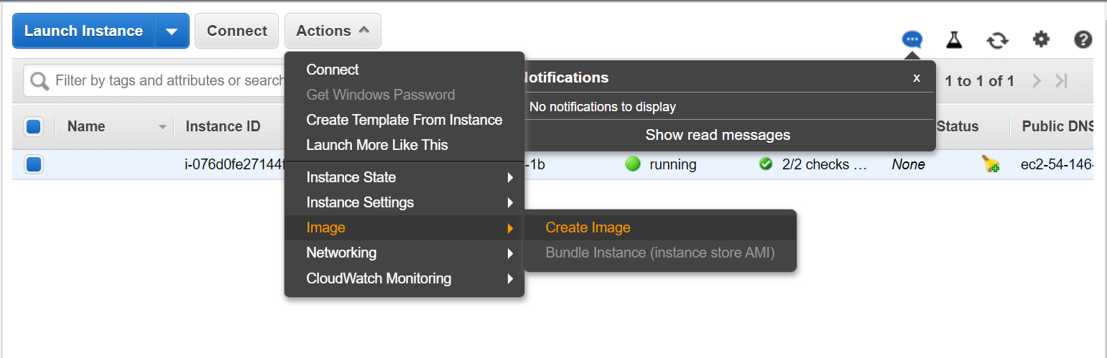

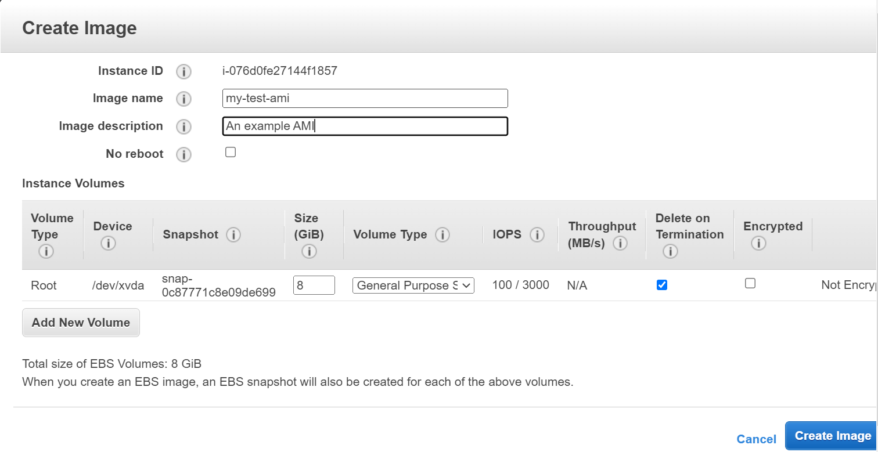

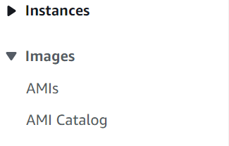

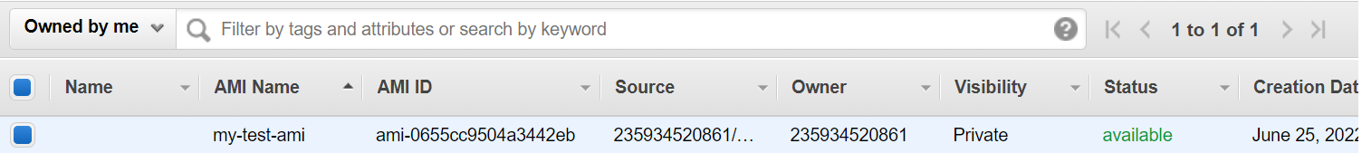

**EC2 Placement groups**

Allows you to specify how instances are places on the underlying hardware. strategies available for grouping or separating instances.

**Types**

Cluster : group instances within a single availability zone. great for low latency, high throughput communication

Spread : offers hardware isolation amongst instances. used to mitigate risk and scope of hardware failures.

Partition: instance are spread across logical partitions. offers some degree of hardware isolation. Instances can communicate within each partition but not across portions

**Create Placement groups**

